Q1. First take a backup of your assignments & projects. This is required because due to incorrect GIT operation you may lose your files.

Q2. Create an empty directory ‘Assignments’ & cd to ‘Assignments’.

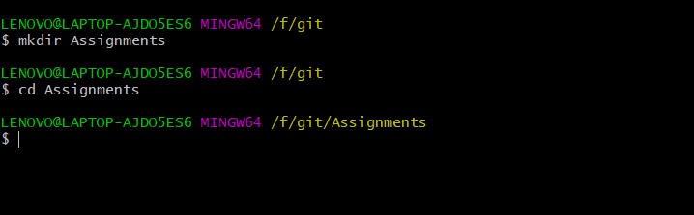

Q3. Create a file README.txt inside ‘Assignments’ & write few lines about the contents of ‘Assignments’ folder.



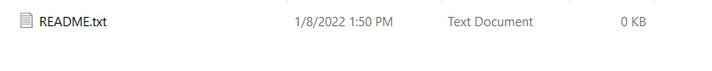

Q4. Commit README.txt file.

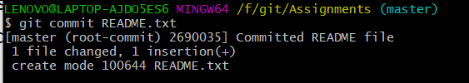

Q5. Now create a new branch ‘html-assignments’.



Q6. Switch to ‘html-assignments’ branch. 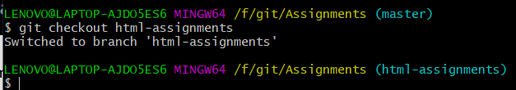

Q7. Copy all HTML assignments inside ‘Assignments’ folder.

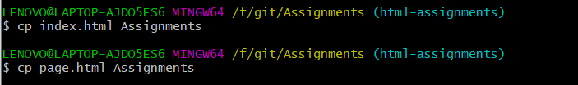

Q8. Commit HTML assignments into ‘html-assignments’ branch.

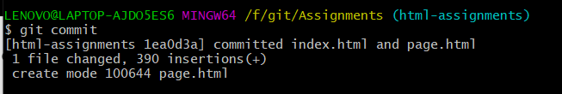

Q9. Make minor changes into few files belonging to ‘html-assignments’ branch.

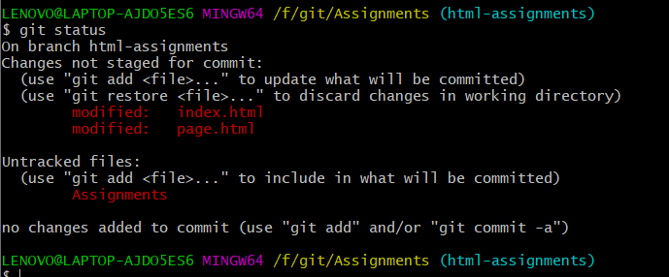

Q10. Commit those changed files.

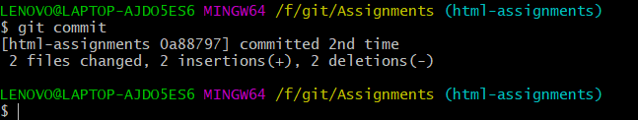

Q11. Switch to master branch.

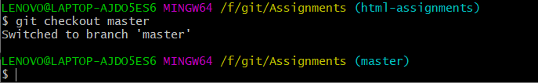

Q12. Make minor changes into README.txt file & commit those changes into master.

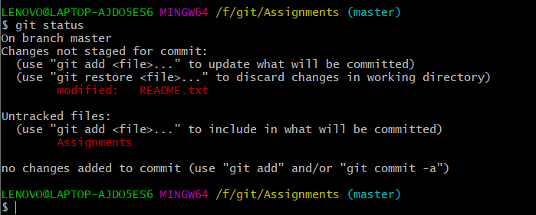

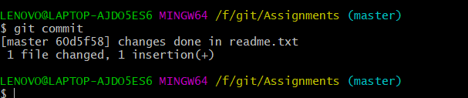

Q13. Again switch to ‘html-assignments’ branch.

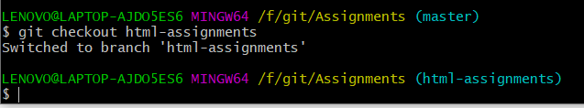

Q14. Make minor changes into few files belonging to ‘html-assignments’ branch.

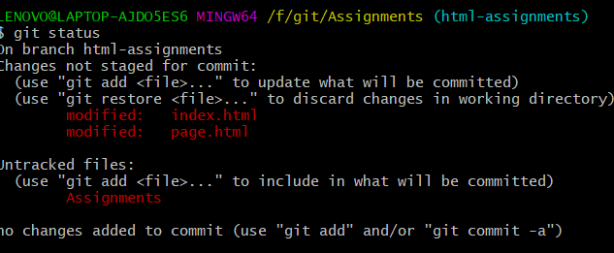

Q15. Commit those changes.

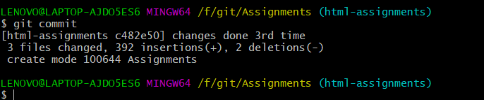

Q16. Switch to master.

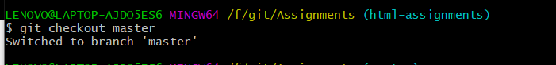

Q17. Merge ‘html-assignments’ branch into master. Confirm all html assignments are shown in master.

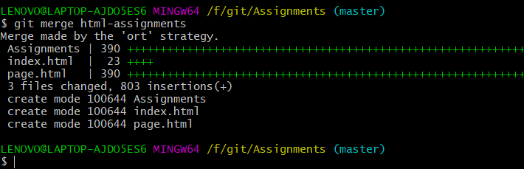

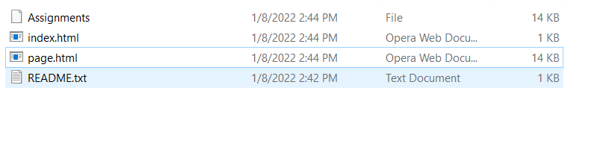

Q18. Finally delete the ‘html-assignments’ branch.

